|  |  |  |  |  |  |  |  |  |
| --- | --- | --- | --- | --- | --- | --- | --- | --- |
| |  | | --- | | Benro Video Tripod - A673TMBS8 Pro | | Product image thumb |  |  |  |  |  | | --- | --- | --- | --- | | Product image thumb | Product image thumb | Product image thumb |  | |  | **Featured information**  The Benro Video - A673TMBS8 Pro tripod is designed specifically for professional filmmakers, possessing a maximum height of 1585mm. The tripod is finished from extremely strong aluminum, withstanding a maximum load of 8kg  **Price: 500$**  **Specifications:**   * **Weight:** 5.45kg * **Max height:** 1585mm * **Minimum height:** 750mm * **Load bearing:** 8 Kg |

**Description:**

#### **Benro Video Tripod - A673TMBS8 Pro**

The Benro Video - A673TMBS8 Pro tripod is designed specifically for professional videographers and photographers. The tripod is made of aluminum in the form of a dual tube, making the tripod extremely sturdy, able to withstand loads up to 8kg, but the weight of the Benro Video - A673TMBS8 Pro tripod is only 5.45kg. Benro Video Tripod - A673TMBS8 Pro is divided into 3 segments with a maximum height of up to 1585mm, a minimum height of 750mm. The underside of the tripod is rubber coated to stand on any surface.

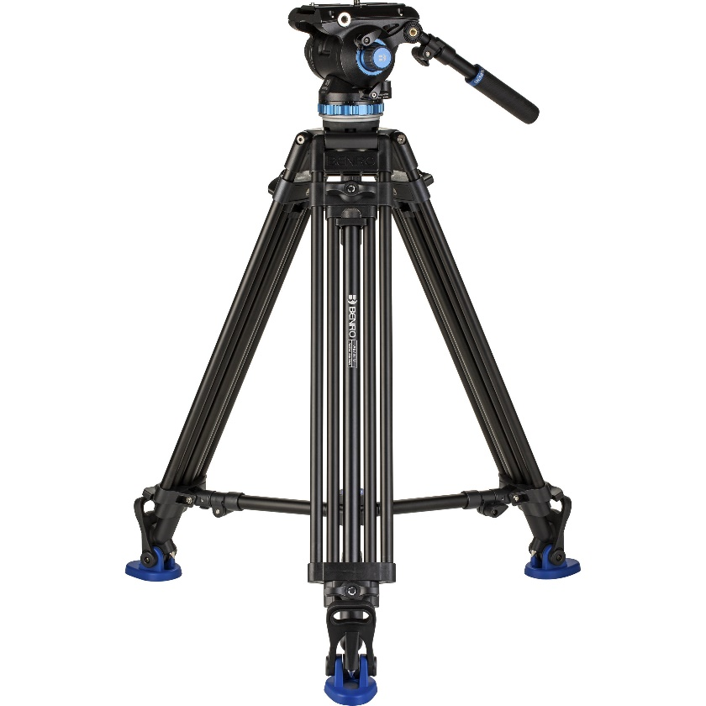

The S8Pro ball head is finished from aluminum and magnesium extremely sturdy so that you can safely place a camera or camcorder weighing up to 8kg without worrying about safety. In addition, the S8Pro ball head of the tripod has a safety lock slide and can be rotated 360 degrees and tilted at a 90 degree angle to help users get creative with their shooting scenes.